Clipping rivers from LA tract map
Jenna
October 1, 2020
## Reading layer `tl_2010_22_tract10' from data source `C:\Users\jenna\Documents\covid-19\inputs\tl_2010_22_tract10\tl_2010_22_tract10.shp' using driver `ESRI Shapefile'
## Simple feature collection with 1148 features and 12 fields
## geometry type: MULTIPOLYGON
## dimension: XY
## bbox: xmin: -94.04335 ymin: 28.85513 xmax: -88.75839 ymax: 33.01954
## geographic CRS: NAD83
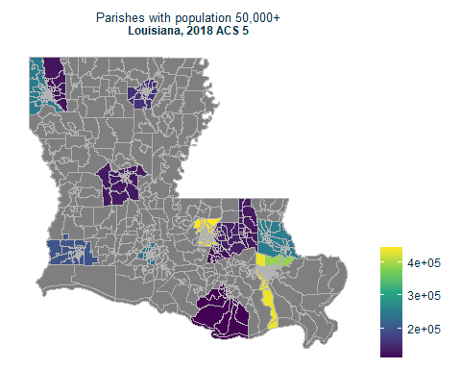
## # A tibble: 14 x 5
## GEOID NAME variable estimate moe
## <chr> <chr> <chr> <dbl> <dbl>
## 1 22005 Ascension Parish, Louisiana DP05_0001 121176 NA
## 2 22015 Bossier Parish, Louisiana DP05_0001 126131 NA
## 3 22017 Caddo Parish, Louisiana DP05_0001 248361 NA
## 4 22019 Calcasieu Parish, Louisiana DP05_0001 200182 NA
## 5 22033 East Baton Rouge Parish, Louisiana DP05_0001 444094 NA
## 6 22051 Jefferson Parish, Louisiana DP05_0001 435300 NA
## 7 22055 Lafayette Parish, Louisiana DP05_0001 240091 NA
## 8 22063 Livingston Parish, Louisiana DP05_0001 138111 NA
## 9 22071 Orleans Parish, Louisiana DP05_0001 389648 NA
## 10 22073 Ouachita Parish, Louisiana DP05_0001 156075 NA
## 11 22079 Rapides Parish, Louisiana DP05_0001 131546 NA
## 12 22103 St. Tammany Parish, Louisiana DP05_0001 252093 NA
## 13 22105 Tangipahoa Parish, Louisiana DP05_0001 130504 NA
## 14 22109 Terrebonne Parish, Louisiana DP05_0001 112587 NA
109:
FID = 724 (Intracoastal waterway through Houma)
079:
FID = 96 (Red River through Alexandria)
073:
FID = 38 (Ouachita River through Monroe)
071:
FID = 507, 286, 320 (MS River through New Orleans)
051:
FID = 40 (MS River through Kenner/Metairie)
033:
FID = 42 (MS River through Baton Rouge)
019:
FID = 96, 509, 374, 148, 504 (Calcasieu River + lakes through Lake Charles)
015:
FID = 67, 152 (Red River through Shreveport)
Parishes without water bodies cutting through areas of dense population 105, 103, 063, 055, 017, 005
## Reading layer `LA tracts clipped rivers parish pop over 100k' from data source `C:\Users\jenna\Documents\covid-19\inputs\LA tracts clipped rivers parish pop over 100k\LA tracts clipped rivers parish pop over 100k.shp' using driver `ESRI Shapefile'
## Simple feature collection with 1148 features and 14 fields
## geometry type: MULTIPOLYGON
## dimension: XY
## bbox: xmin: -94.04335 ymin: 28.85513 xmax: -88.75839 ymax: 33.01954
## geographic CRS: NAD83
