Statewide virus stats update

To go on parish pages, here is an example for New Orleans.
You can find the R script for my code here: covid-19/StateSite/VirusStats_Round2.R

The rate at which there are positive COVID-19 test results is an important indicator that can be used to determine whether Louisiana is adequately testing to detect cases. A high testing positivity rate indicates only the sickest patients are being tested while mild and asymptomatic cases are being missed. Lower positivity indicates sufficient testing capacity for the size of the outbreak. On May 12th, 2020, the World Health Organization advised governments that testing positivity should remain below 5 percent for at least 14 days before reopening.

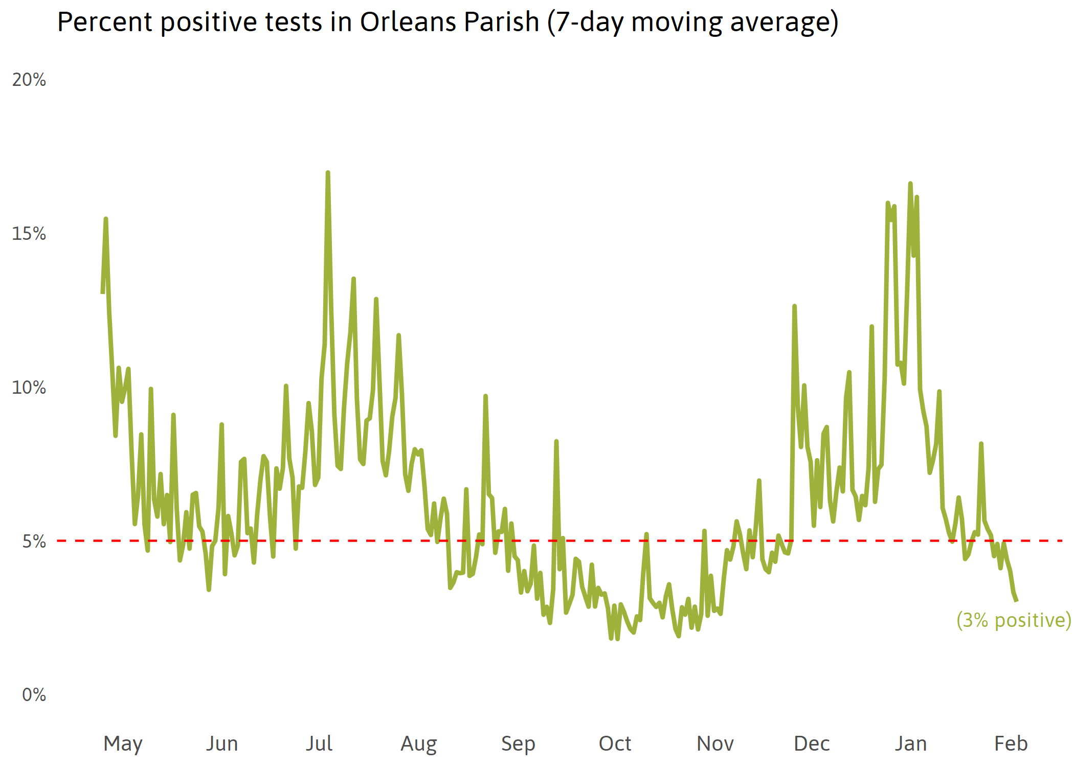
Graph(VirusStateStats/Outputs/Graphs/OrleanstestposChart.png
Download Data (VirusStateStats/Outputs/CSVs/Parishtestpos4CSV.csv
Source: The Data Center analysis of Louisiana Department of Health data.
Notes: This graph only includes Molecular-PCR tests. A rolling 7-day average was calculated separately for daily cases and daily tests, then used to calculate the 7-day moving average of testing positivity for each day. Testing capacity issues and uneven reporting create misleading peaks and valleys in the data. Therefore, averaging raw data and then calculating ratios is the best way to find the 7-day average.

To go on regions page, here is an example for regions page. Here is an example for Region 1.
I included a csv of the population of each region so you can calculate new dotted line threshholds over time. Right now it is at 10% of the region population.
StateSite/Inputs/Region Populations.csv

In the closing weeks of 2020, the first coronavirus vaccine was administered in Louisiana. While vaccines offer a clear solution to the COVID-19 pandemic, they will not single-handedly create a pathway to normalcy. The COVID-19 vaccines work by helping the immune system quickly identify the virus at the start of infection and prevent spread to the rest of the body. This significantly reduces the likelihood of infections developing into severe illness; thus, reducing hospitalizations and death. However, during this time the infected person may still be an asymptomatic carrier of the disease.
Reducing the length and severity of infection likely diminishes, but may not completely eliminate, transmission to others. The more COVID-19 spreads, the more quickly new strains will evolve. Preliminary research suggests currently available vaccines may be less effective against some new strains . The CDC provides regular guidance and information on emerging COVID-19 variant strains.
The vaccine is an important tool to help prevent unnecessary illness and death, slow new strains from emerging, reduce the burden on hospitals and healthcare workers, and in providing the stability needed to build a new economy. Because high inoculation rates are necessary for vaccines to effectively slow the spread of infectious diseases, ensuring high participation rates among the state’s nearly 4.7 million residents is paramount. Importantly, social distancing and mask wearing will continue to be as important as ever.

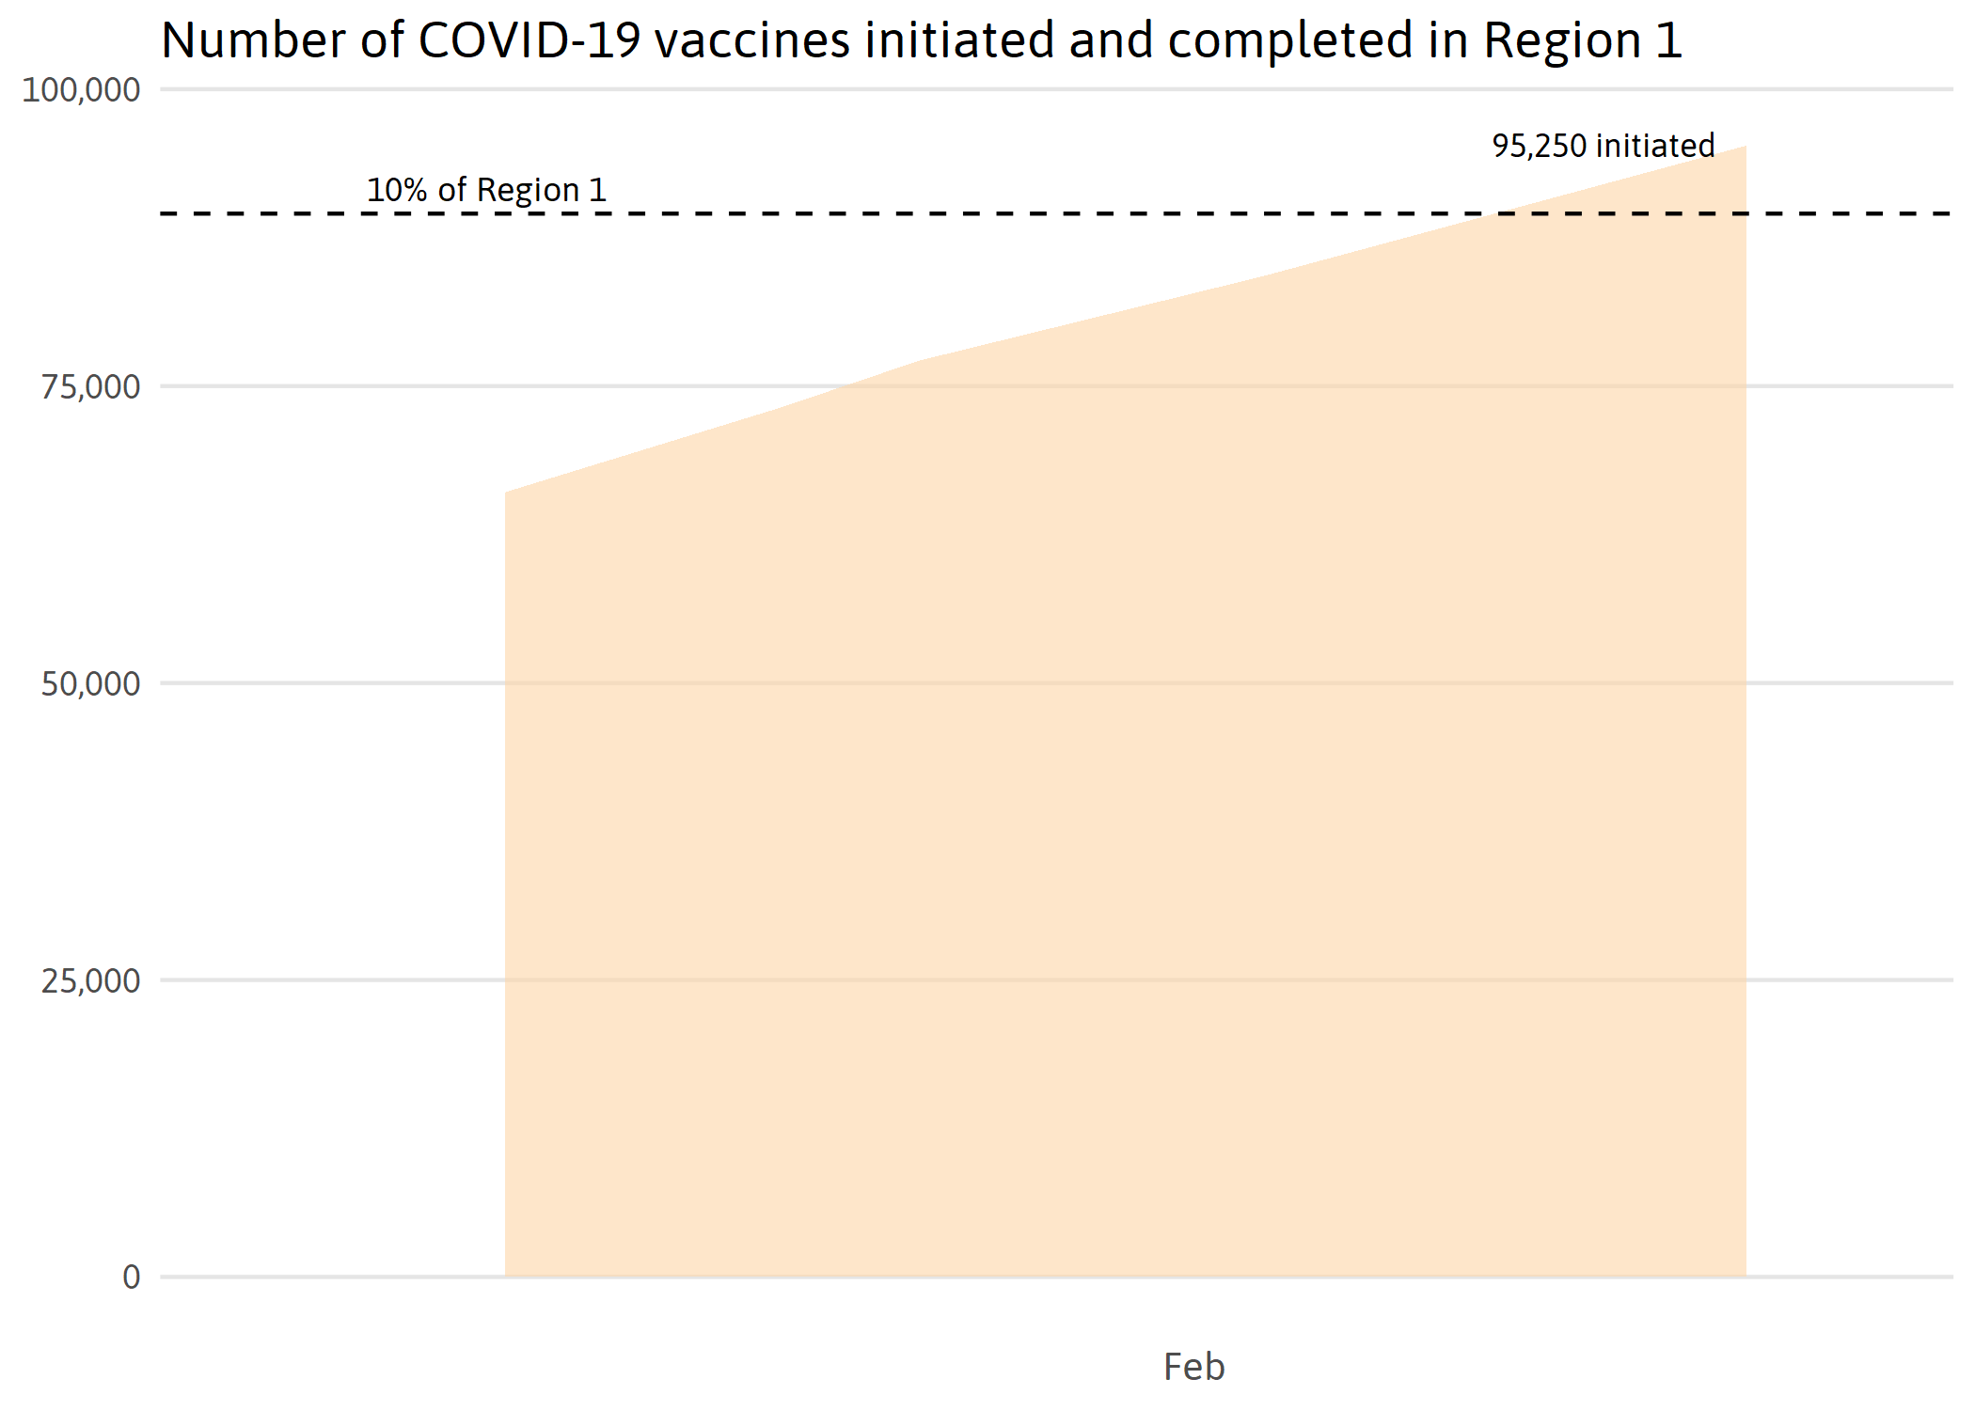
Graph(VirusStateStats/Outputs/Graphs/vaccineChartR1.png)
Download Data (VirusStateStats/Outputs/CSVs/vaccinesRegionsCSV.csv)
Source: The Data Center analysis of Louisiana Department of Health data.
Notes: Several COVID-19 vaccines require two shots. “Initiated” refers to the number of people who have received at least one dose of COVID-19 vaccine in a non-trial setting. LDH updates vaccination data on Tuesdays and Thursdays.

https://coronavirus.jhu.edu/testing/individual-states/louisiana
https://coronavirus.jhu.edu/vaccines/vaccines-faq
Wibmer, C. K., Ayres, F., Hermanus, T., Madzivhandila, M., Kgagudi, P., Lambson, B. E., ... & Moore, P. L. (2021). SARS-CoV-2 501Y. V2 escapes neutralization by South African COVID-19 donor plasma. bioRxiv.
https://www.jnj.com/johnson-johnson-announces-single-shot-janssen-covid-19-vaccine-candidate-met-primary-endpoints-in-interim-analysis-of-its-phase-3-ensemble-trial
https://www.cdc.gov/coronavirus/2019-ncov/vaccines/faq.html#mask

